Day 80

DIY

DIY Questions:

1.Which of the following is not a scheduling mechanism?

a)node selector

b)pod affinity

c)node affinity

d)node anti-affinity

Answer:

**d)node anti-affinity**

2.Which of the following is a QoS class in Kubernetes (select multiple options)?

a)best effort

b)non-guaranteed

c)burstable

d)best support

Answer:

**a)best effort**

**c)burstable**

3.Write a command to taint a worker node using the following key value pair and effect “app=webserver:NoSchedule" ?

Answer:

kubectl taint nodes <node-name> app=webserver:NoSchedule

kubectl taint nodes worker app=webserver:NoSchedule

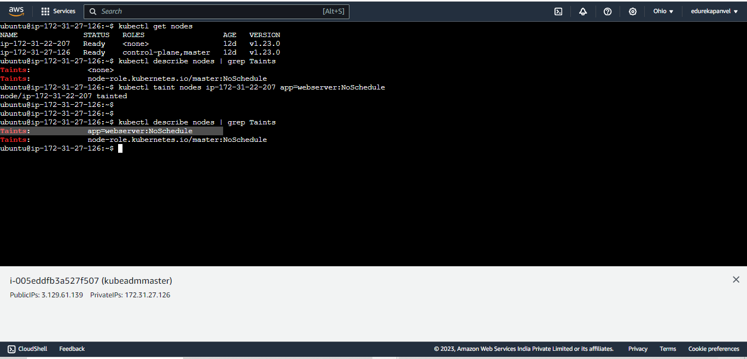

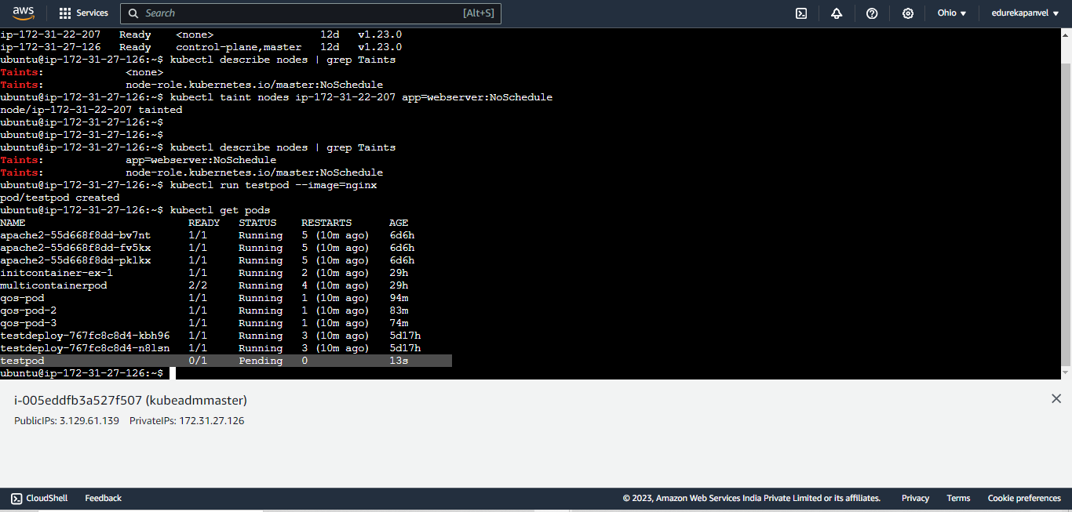

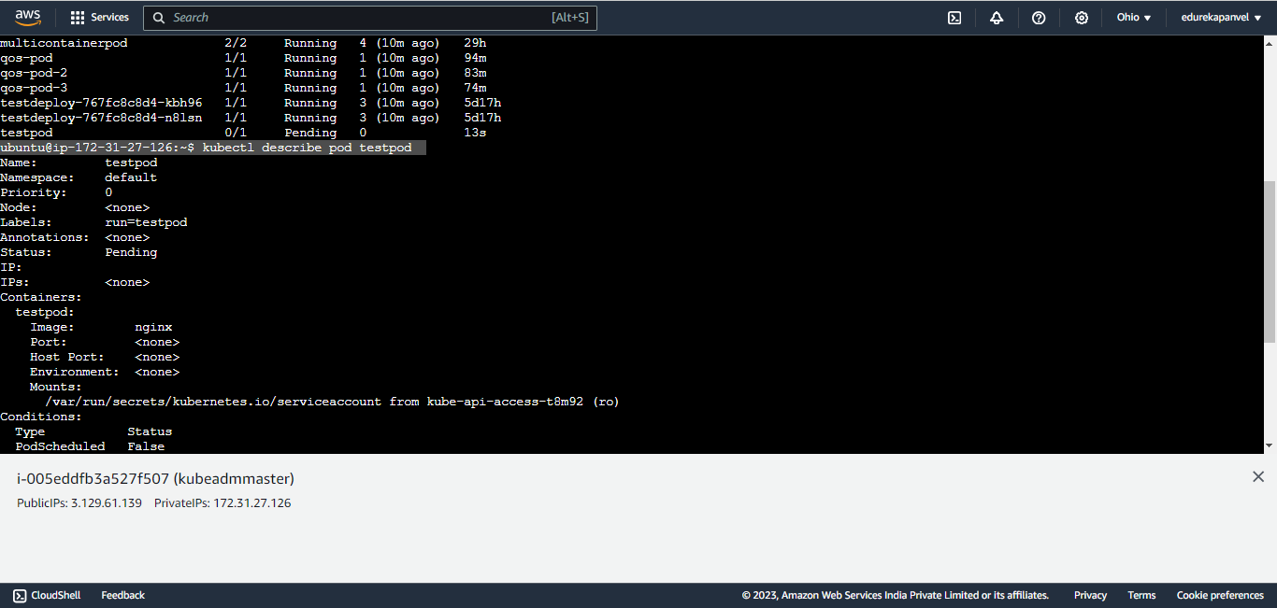

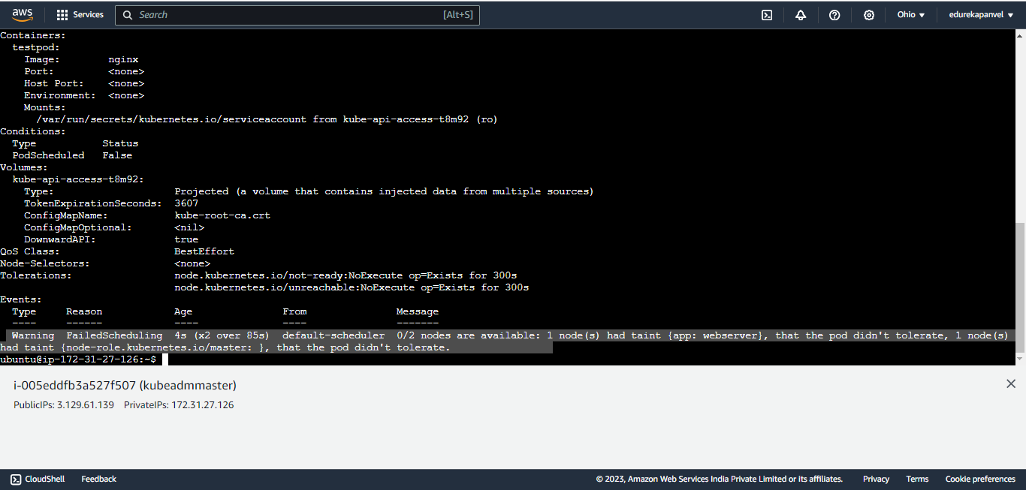

4.How to create a pod on a tainted node using toleration?

Answer:

apiVersion: v1

kind: Pod

metadata:

name: toleration-pod

spec:

tolerations:

- key: "app"

operator: "Equal"

value: "webserver"

effect: "NoSchedule"

containers:

- name: toleration-container

image: nginx:latest

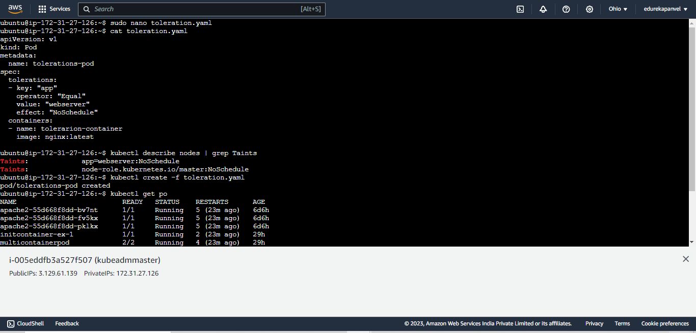

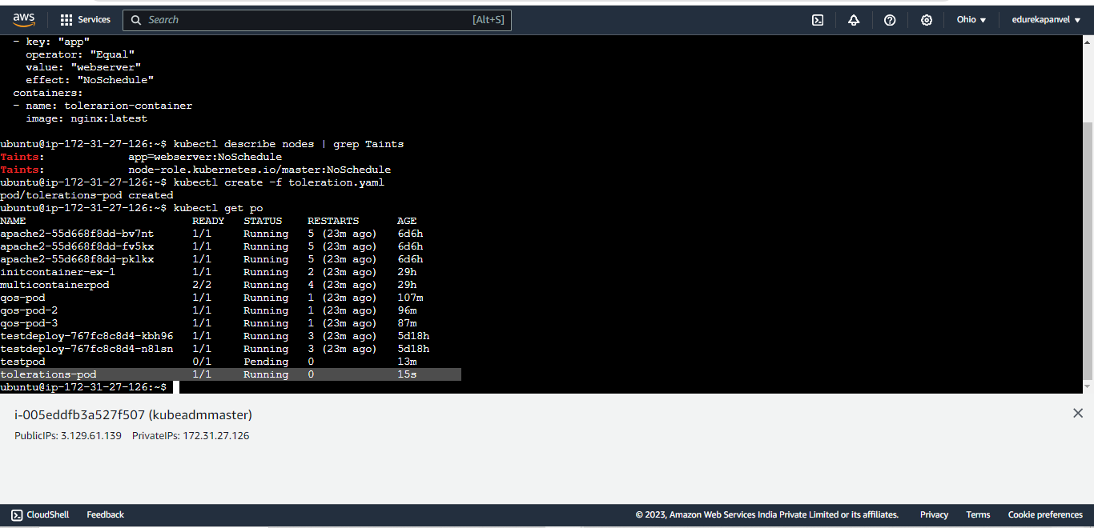

5.Which of the following statement is True about taints

a)taints are always applied on nodes

b)taints are used to stop scheduling of pods on a worker node

c)Pods can be scheduled on a tainted node using tolerations

d)All of the above

Answer:

**d)All of the above**

6. Which of the following is not an effect in taint?

a)NoSchedule

b)NoExecute

c)NoTerminate

d)PreferredNoSchedule

Answer:

**c)NoTerminate**

7. How to create a pod on a node that is tagged using label app=frontend?

Answer:

apiVersion: v1

kind: Pod

metadata:

name: my-pod

labels:

env: test

spec:

containers:

- name: my-nginx-container

image: nginx:latest

imagePullPolicy: IfNotPresent # This sets the image pull policy for the container.

nodeSelector:

app: frontend

